

Cloud Computing Lab 13

Submitted To: Sir Waqas Saleem & Sie Shoaib
Submitted By: Hamail Fatima
Roll No: 2023-BSE-023
Section: 5(A)

Course Name: Cloud Computing

Lab 12 repo link: https://github.com/Hamail-maker/CC_Hamail-Fatima_2023-BSE-023_Lab13.git

Lab # 13

Task 0 Lab Setup (Codespace & GH CLI)
All actions below should be executed inside the Codespace shell.
Create Codespace & connect:
# create or open codespace via GH CLI (example)
gh repo create CC_<YourName>_<YourRollNumber>/Lab13 --public
gh codespace create --repo <user_name>/Lab13
gh codespace list
gh codespace ssh -c <your_codespace_name>
- Save screenshot as: task0_codespace_create_and_list.png — output showing repo creation/codespace list.

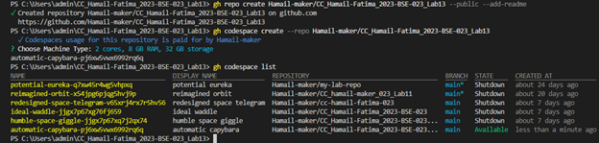

- Save screenshot as: task0_codespace_ssh_connected.png — terminal inside the Codespace shell after ssh.

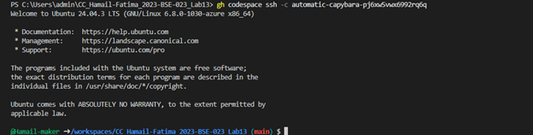

Task 1 — Create IAM Group and Output Details
In this task, you will create an IAM group named "developers" and output its details.
- Create the initial project structure:
mkdir -p ~/Lab13
cd ~/Lab13
- Save screenshot as: task1_project_directory.png — terminal showing directory creation.

- Create the main Terraform file:
touch main.tf
- Save screenshot as: task1_file_created.png — terminal showing file creation.

- Create main.tf with AWS provider configuration:
provider "aws" {
shared_config_files = ["~/.aws/config"]
shared_credentials_files = ["~/.aws/credentials"]
}

resource "aws_iam_group" "developers" {
name = "developers"
path = "/groups/"
}

output "group_details" {
value = {
group_name = aws_iam_group.developers.name
group_arn = aws_iam_group.developers.arn
unique_id = aws_iam_group.developers.unique_id
}
}
- Save screenshot as: task1_main_tf. png — content of main.tf file.

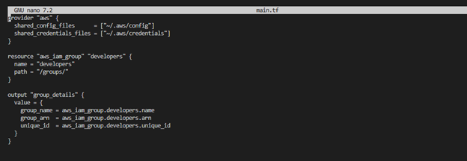

- Initialize Terraform:
terraform init
- Save screenshot as: task1_terraform_init.png — terraform init output.

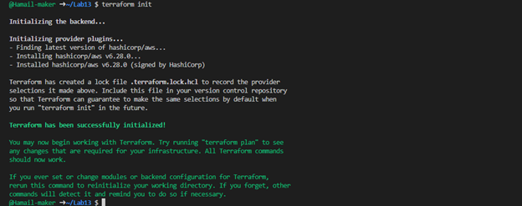

- Apply the configuration:
terraform apply -auto-approve
- Save screenshot as: task1_terraform_apply.png — terraform apply output showing group created.

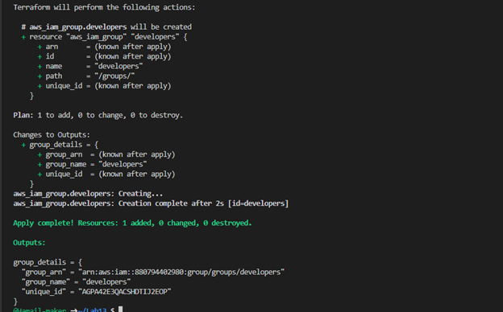

- Display the output:
terraform output
- Save screenshot as: task1_terraform_output.png — terraform output showing group details.

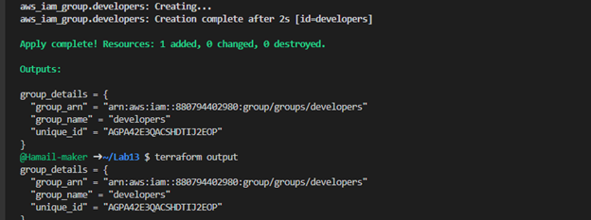

- Verify the group in AWS Console:
- Navigate to IAM → Groups in AWS Console
- Save screenshot as: 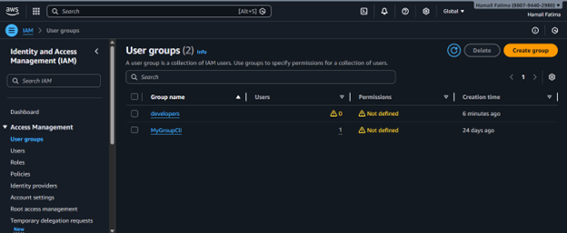— AWS Console showing the developers group.

Task 2 — Create IAM User with Group Membership
In this task, you will create an IAM user named "loadbalancer" and add it to the developers group.
- Update main.tf to add the IAM user resource:
provider "aws" {
shared_config_files = ["~/.aws/config"]
shared_credentials_files = ["~/.aws/credentials"]
}

resource "aws_iam_group" "developers" {
name = "developers"
path = "/groups/"
}

output "group_details" {
value = {
group_name = aws_iam_group.developers. name
group_arn = aws_iam_group. developers.arn
unique_id = aws_iam_group.developers.unique_id
}
}

resource "aws_iam_user" "lb" {
name = "loadbalancer"
path = "/users/"
force_destroy = true
tags = {
DisplayName = "Load Balancer"
}
}

resource "aws_iam_user_group_membership" "lb_membership" {
user = aws_iam_user.lb.name
groups = [
aws_iam_group. developers.name
]
}

output "user_details" {
value = {
user_name = aws_iam_user.lb.name
user_arn = aws_iam_user.lb.arn
unique_id = aws_iam_user.lb.unique_id
}
}
- Save screenshot as: 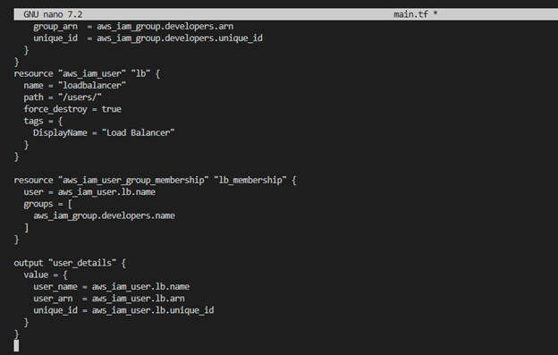— updated main.tf with user resources.

- Apply the configuration:
terraform apply -auto-approve
- Save screenshot as: task2_terraform_apply.png — terraform apply output showing user created.

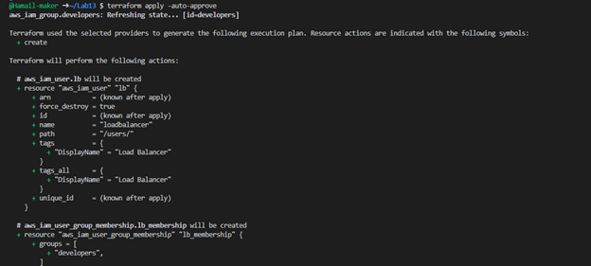

- Display the outputs:
terraform output
- Save screenshot as: task2_terraform_output.png — terraform output showing user and group details.

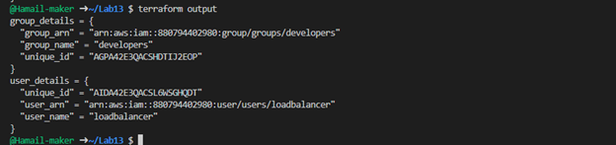

- Verify the user in AWS Console:
- Navigate to IAM → Users in AWS Console
- Click on "loadbalancer" user
- Check the "Groups" tab
- Save screenshot as: task2_aws_console_user.png — AWS Console showing the loadbalancer user.

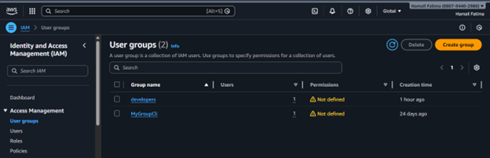

- Save screenshot as: task2_aws_console_user_groups.png — AWS Console showing user's group membership.

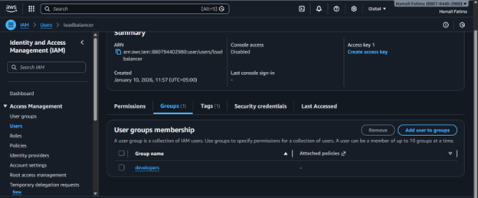

Task 3 — Attach Policies to IAM Group
In this task, you will attach AWS managed policies (AmazonEC2FullAccess and IAMUserChangePassword) to the developers group.
- Update main.tf to add policy attachments:
provider "aws" {
shared_config_files = ["~/.aws/config"]
shared_credentials_files = ["~/.aws/credentials"]
}

resource "aws_iam_group" "developers" {
name = "developers"
path = "/groups/"
}

output "group_details" {
value = {
group_name = aws_iam_group.developers.name
group_arn = aws_iam_group.developers.arn
unique_id = aws_iam_group.developers.unique_id
}
}

resource "aws_iam_user" "lb" {
name = "loadbalancer"
path = "/users/"
force_destroy = true
tags = {
DisplayName = "Load Balancer"
}
}

resource "aws_iam_user_group_membership" "lb_membership" {
user = aws_iam_user.lb.name
groups = [
aws_iam_group.developers.name
]
}

output "user_details" {
value = {
user_name = aws_iam_user.lb.name
user_arn = aws_iam_user.lb.arn
unique_id = aws_iam_user.lb.unique_id
}
}

resource "aws_iam_group_policy_attachment" "developer_ec2_fullaccess" {
group = aws_iam_group.developers.name
policy_arn = "arn:aws:iam::aws:policy/AmazonEC2FullAccess"
}

resource "aws_iam_group_policy_attachment" "change_password" {
group = aws_iam_group.developers.name
policy_arn = "arn:aws:iam::aws:policy/IAMUserChangePassword"
}
- Save screenshot as: \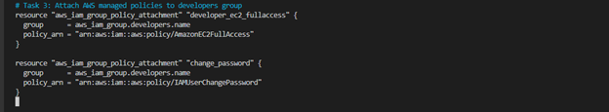— updated main.tf with policy attachments.

- Apply the configuration:
terraform apply -auto-approve
- Save screenshot as: task3_terraform_apply.png — terraform apply output showing policies attached.

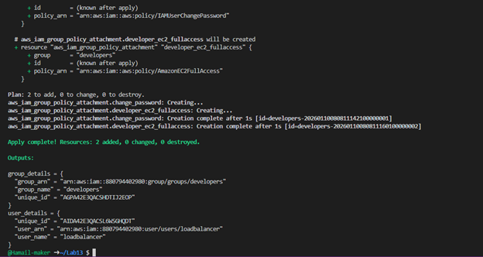

- Verify policies in AWS Console:
- Navigate to IAM → Groups → developers
- Click on "Permissions" tab
- Save screenshot as: task3_aws_console_policies.png — AWS Console showing attached policies.

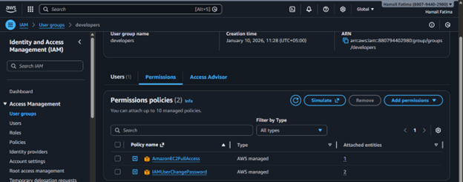

Task 4 — Create Login Profile for IAM User
In this task, you will create a login profile for the loadbalancer user using a bash script and null_resource provisioner.
- Create variables.tf file:
variable "iam_password" {
description = "Temporary password for the IAM user"
type = string
sensitive = true
default = "1dontKnow"
}
- Save screenshot as: task4_variables_tf.png — content of variables.tf file.

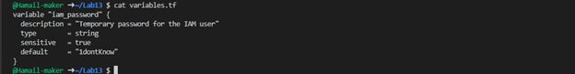

- Create the bash script create-login-profile.sh:
#!/usr/bin/env bash
set -euo pipefail

USERNAME="$1"
PASSWORD="$2"

# Check if login profile already exists
if aws iam get-login-profile --user-name "$USERNAME" >/dev/null 2>&1; then
echo "Login profile already exists for $USERNAME. Skipping."
else
echo "Creating login profile for $USERNAME"
aws iam create-login-profile \
--user-name "$USERNAME" \
--password "$PASSWORD" \
--password-reset-required
fi
- Save screenshot as: task4_create_login_script.png — content of create-login-profile.sh.

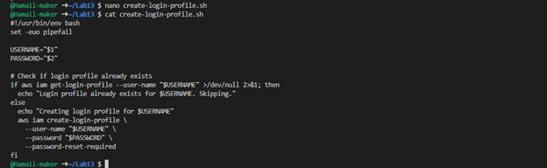

- Make the script executable:
chmod +x create-login-profile.sh
- Save screenshot as: task4_chmod_script.png — terminal showing chmod command.

- Update main.tf to add the null_resource provisioner:
Add this resource after the user creation:
resource "null_resource" "create_login_profile" {
triggers = {
password_hash = sha256(var.iam_password)
user = aws_iam_user.lb.name
}

depends_on = [aws_iam_user. lb]

provisioner "local-exec" {
command = "${path.module}/create-login-profile.sh ${aws_iam_user.lb.name} '${var.iam_password}'"
}
}
- Save screenshot as: task4_main_tf_login_profile.png — main.tf showing null_resource.

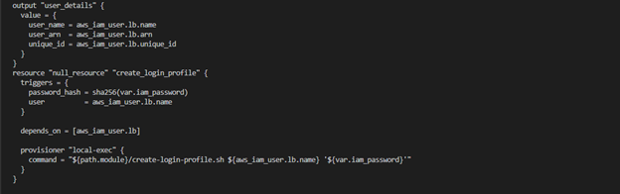

- Apply the configuration with a custom password:
terraform apply -auto-approve -var="iam_password=MySecurePass123!"

- Save screenshot as: task4_terraform_apply.png — terraform apply output showing login profile creation.

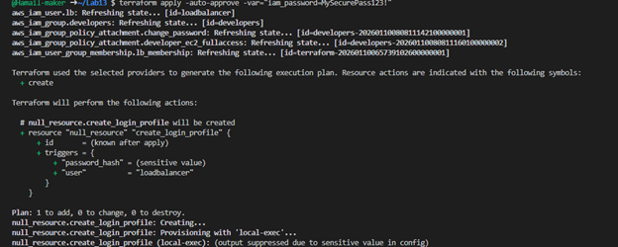

- Verify login profile creation:
aws iam get-login-profile --user-name loadbalancer
- Save screenshot as: task4_aws_cli_verify.png — AWS CLI output showing login profile.

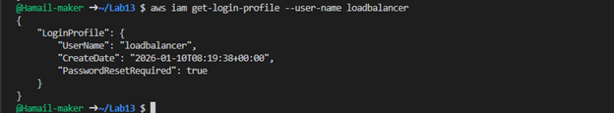

- Test login in AWS Console:
- Open AWS Console login page
- Sign in as IAM user with username "loadbalancer" and the password you set
- You should be prompted to change password
- Save screenshot as: task4_aws_console_login.png — AWS Console login page with IAM user.

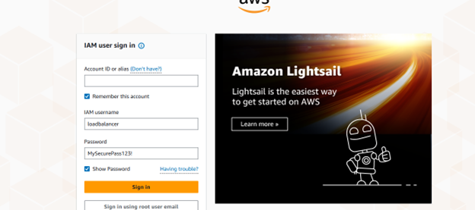

- Save screenshot as: task4_aws_console_password_reset.png — Password reset prompt.

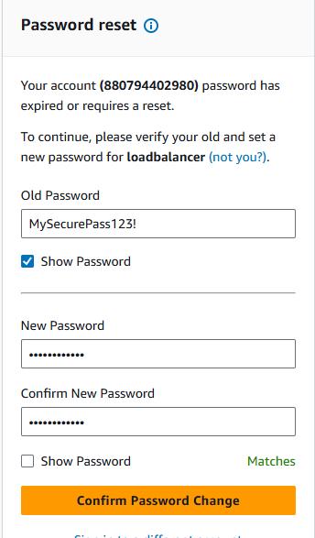

Task 5 — Generate Access Keys for IAM User
In this task, you will create access keys for the loadbalancer user and view them in terraform state.
- Update main.tf to add access key resource and outputs:
Add these resources:
resource "aws_iam_access_key" "lb_access_key" {
user = aws_iam_user.lb.name
}

output "access_key_id" {
value = aws_iam_access_key.lb_access_key.id
}

output "access_key_secret" {
value = aws_iam_access_key.lb_access_key. secret
sensitive = true
}
- Save screenshot as: task5_main_tf_access_keys.png — main.tf showing access key resources.

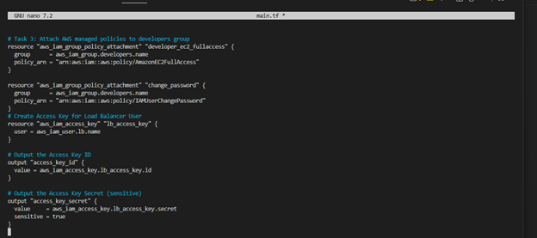

- Apply the configuration:
terraform apply -auto-approve -var="iam_password=MySecurePass123!"
- Save screenshot as: task5_terraform_apply.png — terraform apply output showing access key created.

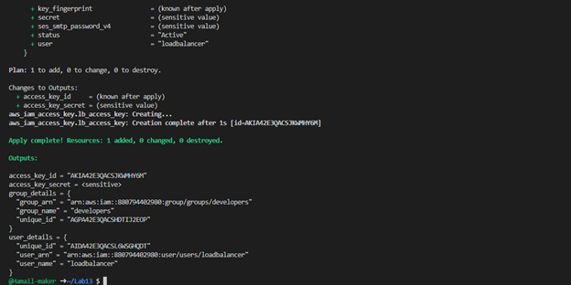

- Display outputs:
terraform output
- Save screenshot as: task5_terraform_output.png — terraform output showing access_key_id but hidden secret.

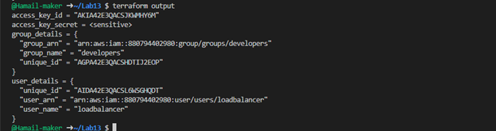

- View the secret in terraform state:
cat terraform.tfstate | grep -A 10 "access_key_secret"
- Save screenshot as: task5_tfstate_secret.png — terraform.tfstate showing access key secret.

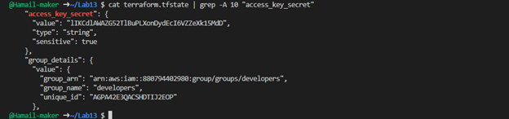

- Verify access key in AWS Console:
- Navigate to IAM → Users → loadbalancer → Security credentials
- Save screenshot as: task5_aws_console_access_keys.png — AWS Console showing access keys.

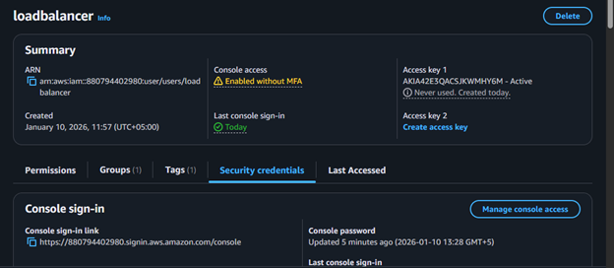

Task 6 — Implement Terraform Remote State with S3
In this task, you will configure Terraform to use S3 backend for remote state storage.
- Create S3 bucket in AWS Console:
- Navigate to S3 in AWS Console
- Click "Create bucket"
- Bucket name: myapp-s3-bucket-demo (use a unique name if this is taken)
- Enable versioning
- Keep other settings as default
- Click "Create bucket"
- Save screenshot as: task6_s3_bucket_create.png — S3 bucket creation page.

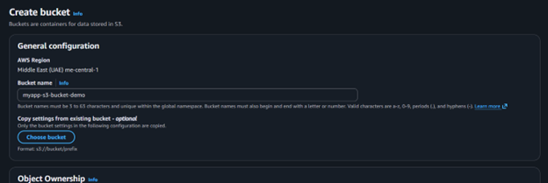

- Save screenshot as: 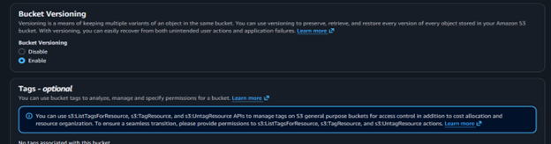— S3 bucket with versioning enabled.

- Update main.tf to add S3 backend configuration:
Add this at the beginning of main.tf (before the provider block):
terraform {
backend "s3" {
bucket = "myapp-s3-bucket-demo"
key = "myapp/terraform.tfstate"
region = "me-central-1"
encrypt = true
use_lockfile = true
}
}
- Save screenshot as: 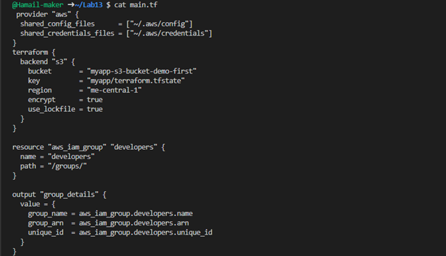— main.tf showing backend configuration.

- Reinitialize Terraform with the backend:
terraform init -migrate-state
- Type yes when prompted to migrate state
- Save screenshot as: task6_terraform_init_migrate.png — terraform init output showing state migration.

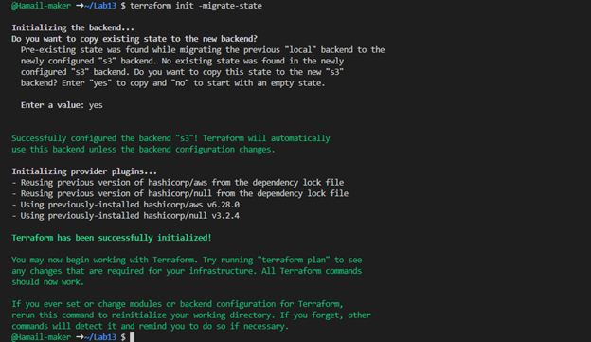

- Apply the configuration:
terraform apply -auto-approve -var="iam_password=MySecurePass123!"

- Save screenshot as: task6_terraform_apply.png — terraform apply with remote state.

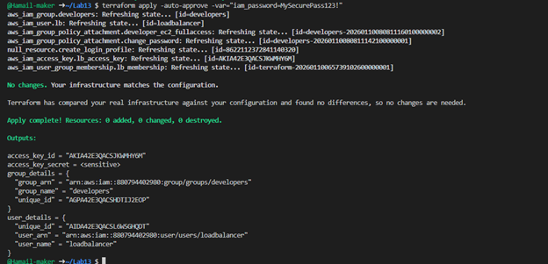

- Verify state file in S3:
- Navigate to S3 → myapp-s3-bucket-demo → myapp/
- You should see terraform.tfstate file
- Save screenshot as: task6_s3_tfstate_file.png — S3 bucket showing terraform.tfstate file.

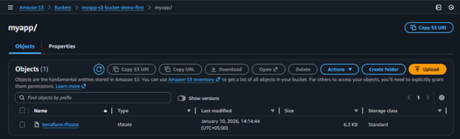

- Check local state file:
ls -la terraform.tfstate*
- Save screenshot as: task6_local_state_backup.png — showing local state backup file.

- Destroy resources and verify state change:
terraform destroy -auto-approve
- Save screenshot as: task6_terraform_destroy.png — terraform destroy output.

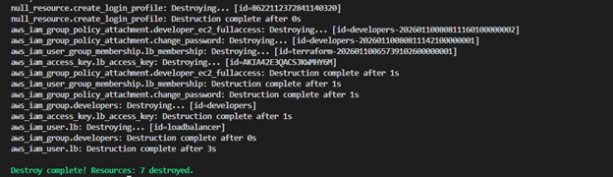

- Verify updated state in S3:
- Refresh S3 bucket view
- Check the terraform.tfstate file (it should show empty resources)
- Save screenshot as: task6_s3_tfstate_destroyed.png — S3 state file after destroy.

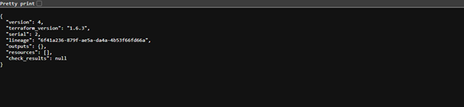

Task 7 — Create Multiple Users from CSV File
In this task, you will create multiple IAM users dynamically from a CSV file.
- Create locals.tf file:
locals {
users = csvdecode(file("users.csv"))
}
- Save screenshot as: task7_locals_tf.png — content of locals.tf file.

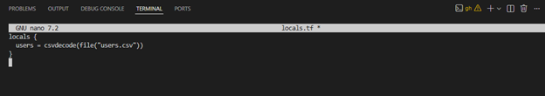

- Create users.csv file:
user_name
Michael
Dwight
Jim
Pam
Ryan
Andy
Robert
Stanley
Kevin
Angela
Oscar
Phyllis
Toby
Kelly
Darryl
Creed
Meredith
Erin
Gabe
Jan
David
Holly
Charles
Jo
Clark
Peter
- Save screenshot as: task7_users_csv.png — content of users.csv file.

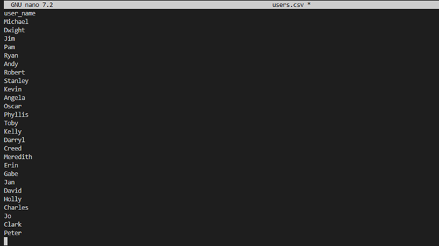

- Update main.tf to create multiple users:
Replace the single user resources with:
# Create multiple IAM users from CSV
resource "aws_iam_user" "users" {
for_each = { for user in local.users : user.user_name => user }

name = each.value.user_name
path = "/users/"
force_destroy = true

tags = {
DisplayName = each.value.user_name
CreatedBy = "Terraform"
}
}

# Add all users to developers group
resource "aws_iam_user_group_membership" "users_membership" {
for_each = aws_iam_user.users

user = each.value.name
groups = [
aws_iam_group.developers.name
]
}

# Create login profiles for all users
resource "null_resource" "create_login_profiles" {
for_each = aws_iam_user.users

triggers = {
password_hash = sha256(var. iam_password)
user = each.value.name
}

depends_on = [aws_iam_user. users]

provisioner "local-exec" {
command = "${path. module}/create-login-profile. sh ${each.value.name} '${var.iam_password}'"
}
}

# Create access keys for all users
resource "aws_iam_access_key" "users_access_keys" {
for_each = aws_iam_user. users

user = each.value.name
}

# Output all user details
output "all_users_details" {
value = {
for user_name, user in aws_iam_user.users : user_name => {
user_arn = user.arn
user_unique_id = user.unique_id
access_key_id = aws_iam_access_key.users_access_keys[user_name].id
}
}
}

# Output all access key secrets (sensitive)
output "all_access_key_secrets" {
value = {
for user_name, key in aws_iam_access_key.users_access_keys : user_name => key.secret
}
sensitive = true
}
- Save screenshot as: task7_main_tf_multiple_users.png — main.tf showing multiple user resources.
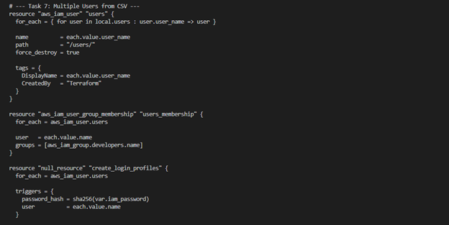

- Reinitialize Terraform (since we changed the configuration significantly):
terraform init
- Save screenshot as: 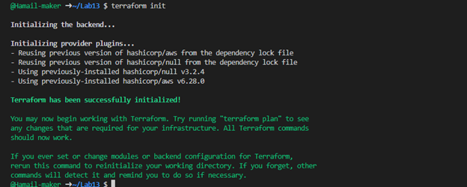— terraform init output.

- Apply the configuration to create all users:
terraform apply -auto-approve -var="iam_password=MySecurePass123!"
- Save screenshot as: task7_terraform_apply.png — terraform apply output showing all users being created.

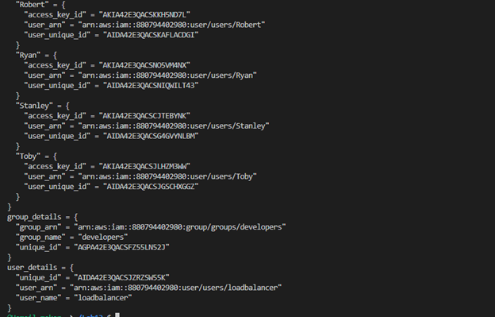

- Display the outputs:
terraform output
- Save screenshot as: task7_terraform_output.png — terraform output showing all user details.

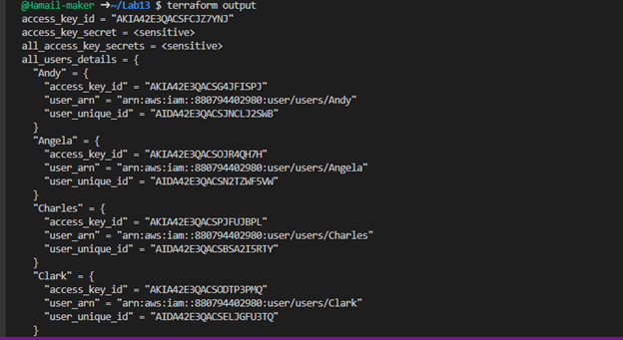

- View secrets in terraform. tfstate:
cat terraform.tfstate | grep -A 5 "all_access_key_secrets"
- Save screenshot as: task7_tfstate_secrets.png — terraform.tfstate showing access key secrets.

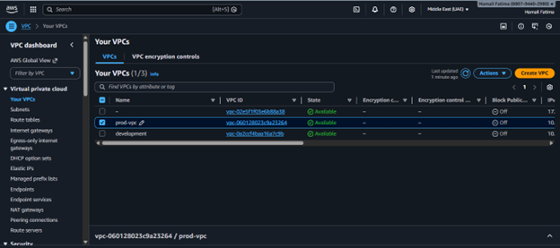

- Verify all users in AWS Console:
- Navigate to IAM → Users
- Save screenshot as: task7_aws_console_all_users.png — AWS Console showing all created users.

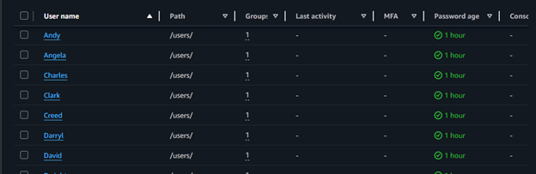

- Verify group membership:
- Navigate to IAM → Groups → developers → Users tab
- Save screenshot as: task7_aws_console_group_members.png — AWS Console showing all users in developers group.



- Verify one user's access keys:
- Click on any user (e.g., "Michael")
- Go to Security credentials tab
- Save screenshot as: task7_aws_console_user_access_key.png — AWS Console showing user's access key.

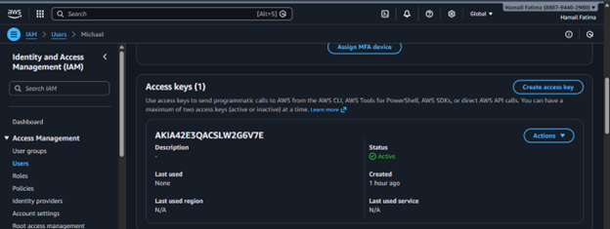

- Check terraform state in S3:
- Navigate to S3 bucket and view the state file
- Save screenshot as: task7_s3_tfstate_multiple_users.png — S3 showing updated state file.

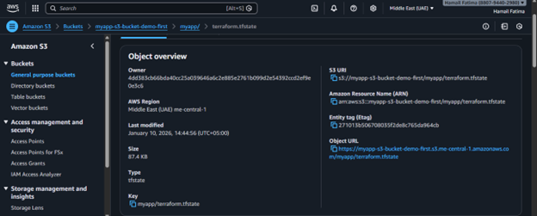

Cleanup
- Destroy all resources:
terraform destroy -auto-approve
- Save screenshot as: cleanup_destroy_complete.png — terraform destroy completion output.

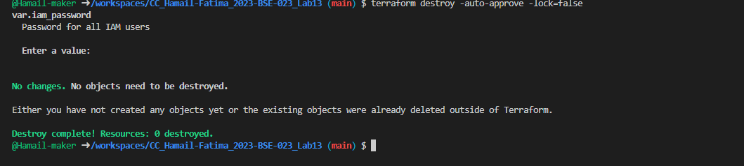

- Verify users deleted in AWS Console:
- Navigate to IAM → Users
- Save screenshot as: cleanup_aws_console_users_deleted.png — AWS Console showing no users.

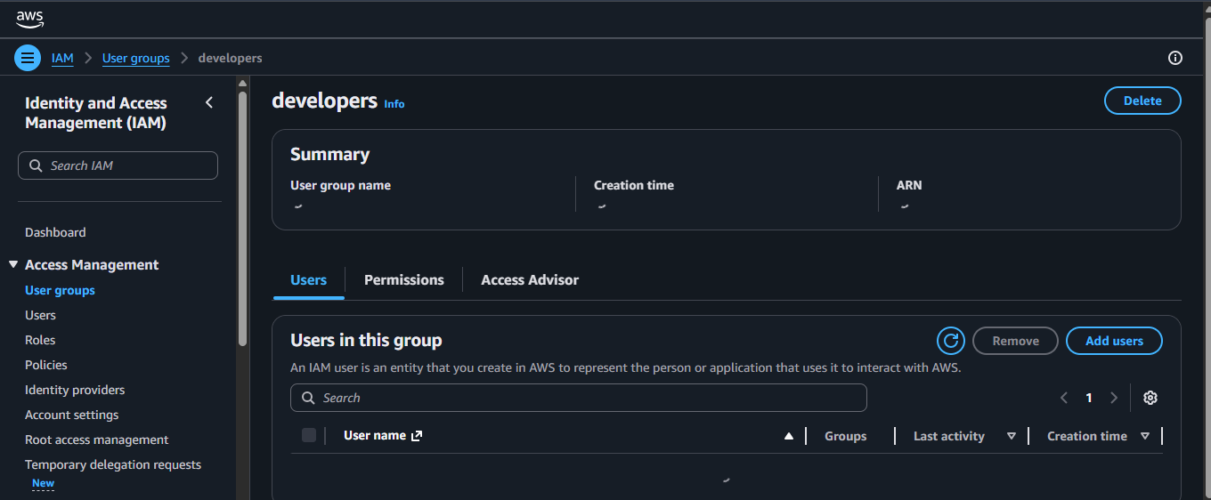

- Verify group deleted in AWS Console:
- Navigate to IAM → Groups
- Save screenshot as: cleanup_aws_console_group_deleted.png — AWS Console showing developers group deleted.

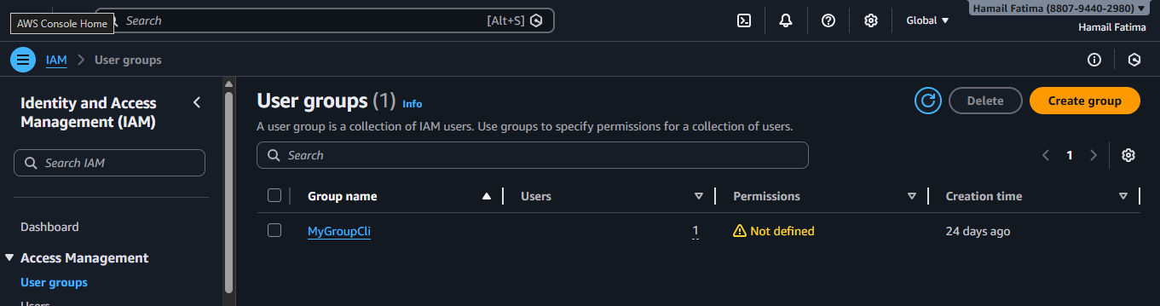

- Check S3 state file:
- Navigate to S3 bucket
- Save screenshot as: cleanup_s3_empty_state.png — S3 showing empty state.

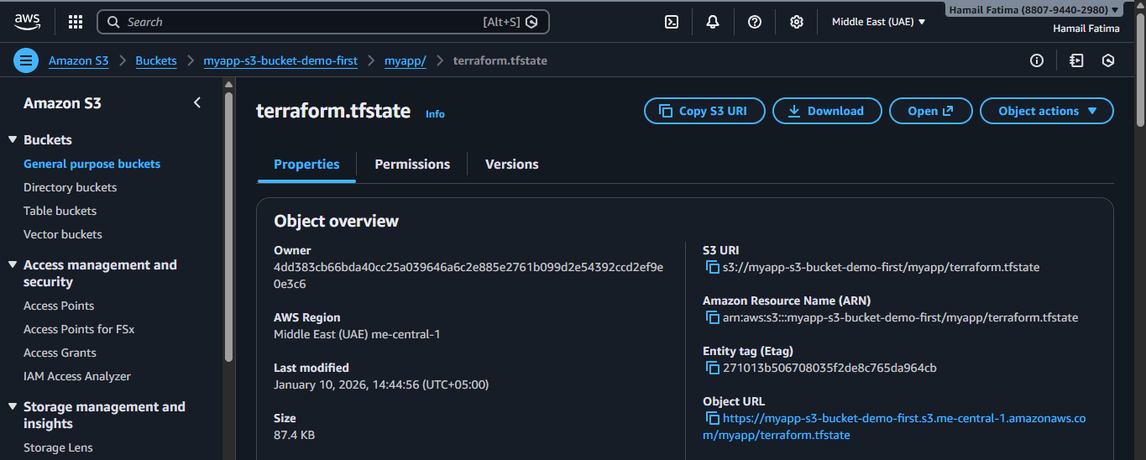

- List all project files:
ls -la
- Save screenshot as: cleanup_final_files.png — showing final project structure.

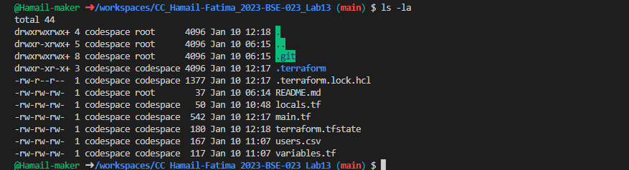

- (Optional) Delete S3 bucket:
- If you want to clean up completely, delete the S3 bucket from AWS Console
- Save screenshot as: cleanup_s3_bucket_deleted. png — S3 bucket deletion confirmation.

